

12 January 2022

**Terra Industrial New Zealand Ltd**

PO Box 16 168

16 Branston Street, Hornby

Christchurch 8441, New Zealand

03 983 2333 Tel

www.TerraCat.co.nz

**Syncing Contacts and Calendars on Phone from Outlook**

1. Open the Outlook App on your phone
2. Click on your logo at the top left

1. Click on the settings wheel at the bottom left

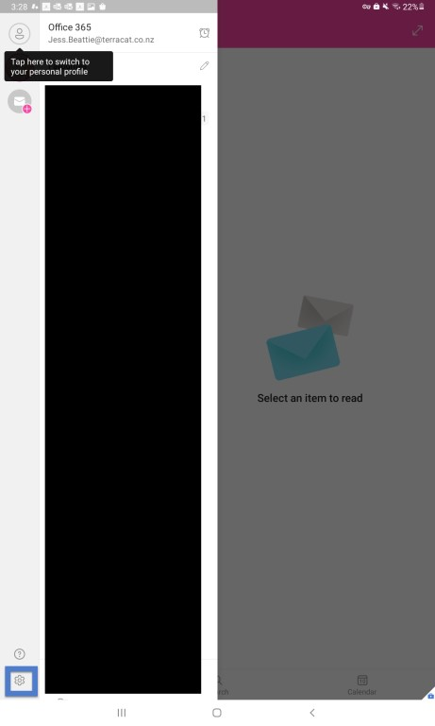

1. Select your email address

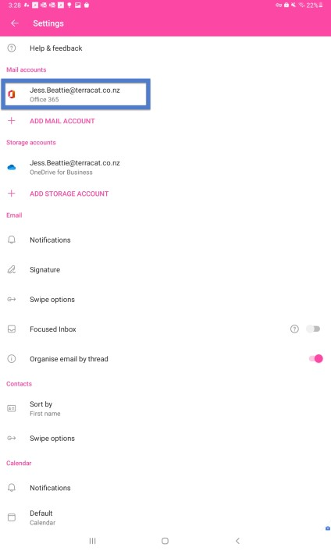

1. Turn on **Sync Contacts and Sync Calendars** then select **Allow** on the popup for both like below

